
FACULTY OF TECHNOLOGY AND ENGINEERING
DEVANG PATEL INSTITUTE OF ADVANCE TECHNOLOGY
AND RESEARCH

DEPARTMENT OF COMPUTER ENGINEERING

A.Y 2026 – 27 Semester – 3

LAB MANUAL

CSUC201 Fundamentals of Data Structures and Algorithms

Practical 5: Doubly Linked List and Circular Linked List Operations
Practical Aim:
To implement core doubly linked list and circular linked list operations and understand how bidirectional and circular linking change the way nodes are inserted, deleted, and traversed.
Problem 1 :
A music player maintains a playlist where songs can be added to the beginning, added to the end, or inserted right after a specific song that is currently playing. When a song is removed, only the first song in the playlist is dropped. At any point the player can count how many songs are in the playlist and display them from first to last. Given a sequence of such operations, implement all of them on a doubly linked playlist and print the result after each operation.
Describe how your insertion after a given song works. What extra step does a doubly linked list require here that a singly linked list did not? What happens if the given song is not found in the playlist?

Link:

Output:
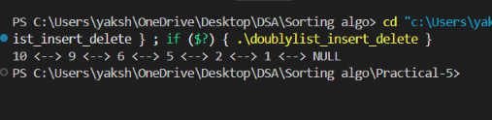
Conclusion:
The program implements a doubly linked playlist with insertion at the beginning, end, and after a specific song. It updates both next and prev links correctly and handles the case when the song is not found.

Problem 2
A group of students are sitting in a circle playing a passing game. A token starts at the first student and is passed around the circle one student at a time. Students can join the circle at any position and leave at any time, and the circle must remain unbroken after every join or leave. Given a sequence of join, leave, and display operations, implement them on both a singly circular and a doubly circular linked list and print the current circle after each operation.
Describe how your solution ensures the circle stays unbroken after a student leaves. What is the one case where breaking the circle is most likely to happen as a bug, and how did you handle it?

Link:

Output:
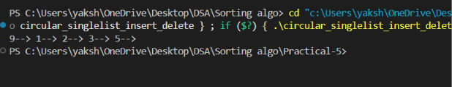
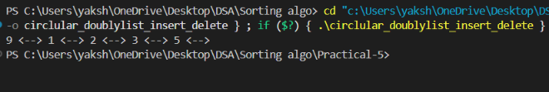
Conclusion:
The program implements singly and doubly circular linked lists while maintaining continuous circular links after every join and leave operation. The special case of deleting the only student is handled separately to avoid breaking the circle.

Key Questions / Analysis / Interpretation to be Evaluated During/After
Implementation :

[Problem 1] A doubly linked list maintains two links per node instead of one. When deleting the front node, explain why having a backward link on the second node creates a responsibility that did not exist in a singly linked list — and what goes wrong if you forget to handle it.
Sol:
When deleting the front node, the new front node’s prev pointer must be set to NULL. If not, it still points to the deleted node, creating a dangling pointer and causing incorrect behavior or crashes.

[Problem 2] If your traversal of the circular list does not stop at the right moment, it will loop forever. Without referencing any specific code, explain what condition must be true at the moment you stop, and why that condition would fail if you set the last node's link to null.
Sol:
Traversal should stop when you reach the starting node again, because the last node links back to the first node.
If the last node’s link is set to NULL, traversal cannot return to the starting node and the circular structure is broken.

